**LOK NAYAK JAIPRAKASH INSTITUTE OF TECHNOLOGY CHAPRA, BIHAR**

**Department of CSE**

**021202 Engineering Graphics**

**Assignment II**

1. Draw a scale of 1:60 to show meters and decimeters and long enough to measure up to 6 meters.

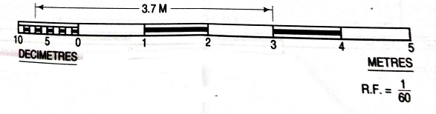

1. Construct a diagonal scale of 3:200 i.e. 1:66 $\frac{2}{3}$ showing meters, decimeters and centimeters and to measure up to 6 meters.

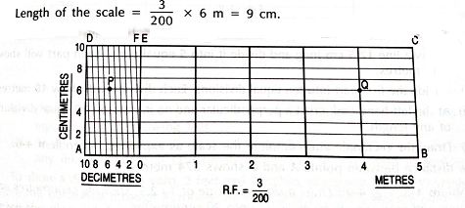

1. Construct a scale of R.F.= $\frac{1}{84480}$ to show miles and furlongs and long enough to measure upto 6 miles.

